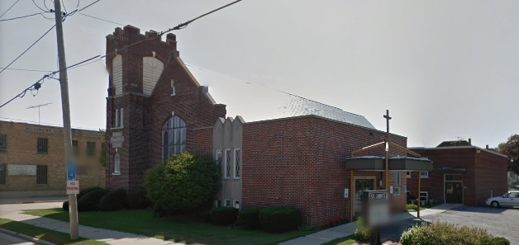

1501 Marshall Street

Grow It Forward

Farmers Market Applications

South Door

